Crossed Heptagrammic Cupola
# Source: AI Source: Provided by: [Data Path: Persons Table -> ID Column: 1, Name_En Column: Motasem Essam] -> From: [ChatGPT] on [7/25/2026]
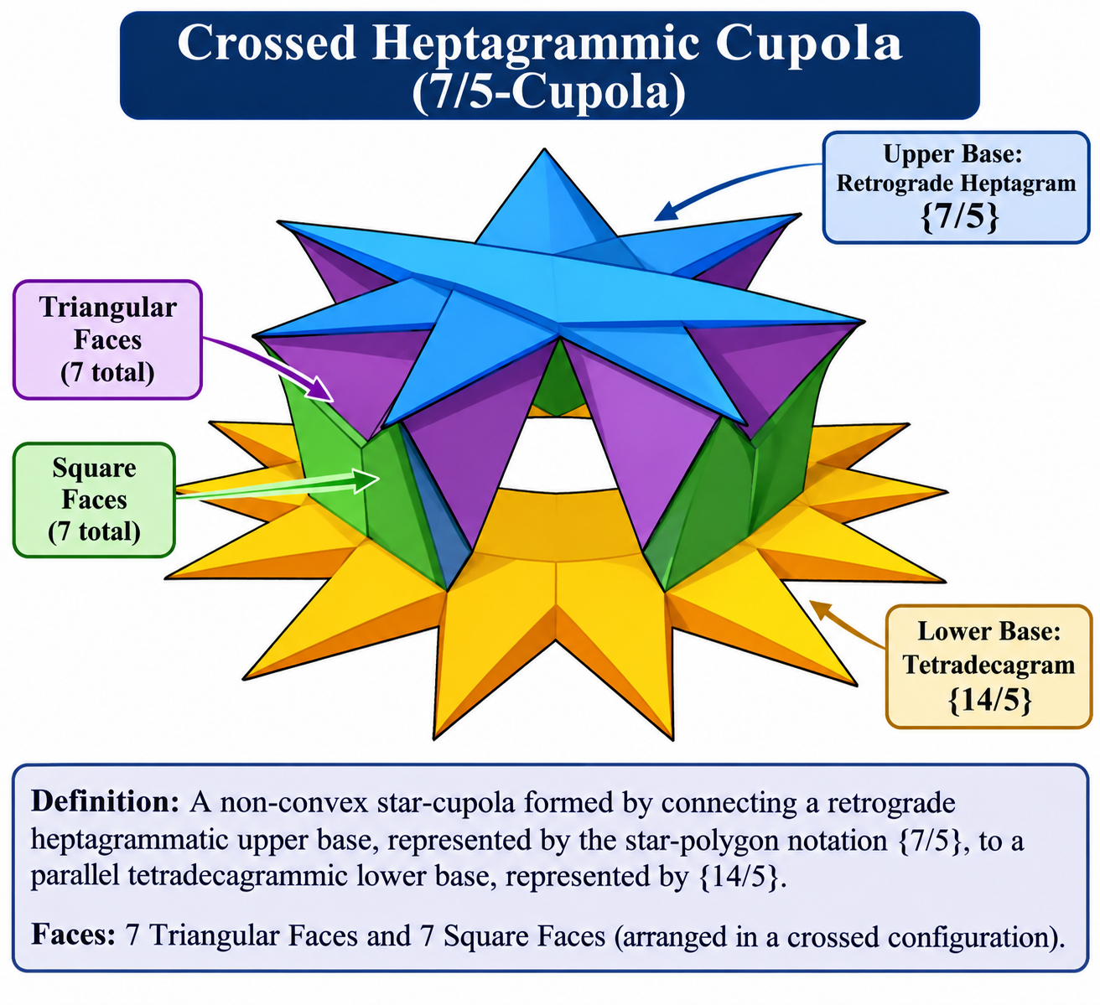

Definition
# Source: AI Source: Provided by: [Data Path: Persons Table -> ID Column: 1, Name_En Column: Motasem Essam] -> From: [ChatGPT] on [7/25/2026]
A Crossed Heptagrammic Cupola, also known as a 7/5-Cupola or Retrograde Heptagrammic Cupola, is a non-convex star-cupola formed by connecting a retrograde heptagrammatic upper base to a parallel tetradecagrammic lower base.
It is constructed using the star-polygon notation $\{7/5\}$ for the upper base and $\{14/5\}$ for the lower base. Its lateral structure consists of seven triangular faces and seven square faces arranged in a crossed configuration. <Cite refs={["turn432429search6","turn432429search12","turn432429search10"]}/>
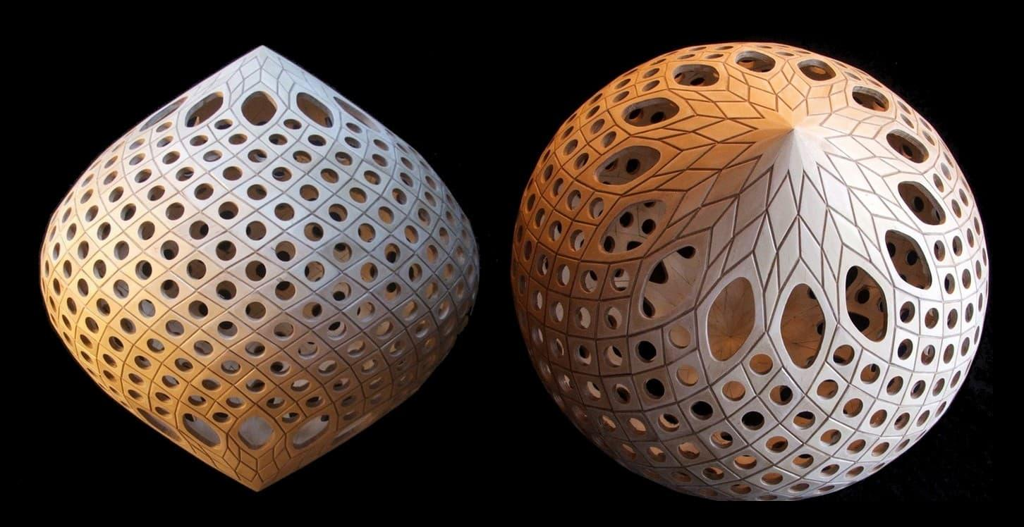

Geometric Structure
# Source: AI Source: Provided by: [Data Path: Persons Table -> ID Column: 1, Name_En Column: Motasem Essam] -> From: [ChatGPT] on [7/25/2026]
The Crossed Heptagrammic Cupola consists of:
- Upper Base: A retrograde heptagram represented by the star-polygon notation $\{7/5\}$.
- Lower Base: A tetradecagram represented by the star-polygon notation $\{14/5\}$.
- Triangular Faces: Seven equilateral triangular lateral faces.
- Square Faces: Seven square lateral faces.
- Crossed Arrangement: The lateral faces connect the two bases according to the retrograde heptagram's vertex sequence.
<Cite refs={["turn432429search6","turn432429search12"]}/>

Face Composition
# Source: AI Source: Provided by: [Data Path: Persons Table -> ID Column: 1, Name_En Column: Motasem Essam] -> From: [ChatGPT] on [7/25/2026]
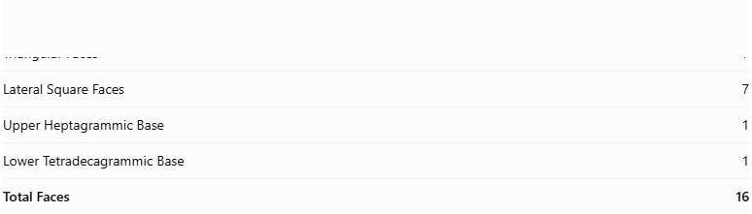
Face Type | Number
Triangular Faces | 7
Lateral Square Faces | 7
Upper Heptagrammic Base | 1
Lower Tetradecagrammic Base | 1
Total Faces | 16
The two bases are star polygons, while the fourteen lateral faces form the connecting structure. <Cite refs={["turn432429search6"]}/>

Mathematical Properties
# Source: AI Source: Provided by: [Data Path: Persons Table -> ID Column: 1, Name_En Column: Motasem Essam] -> From: [ChatGPT] on [7/25/2026]

Property | Value
Total Faces (F) | 16
Total Edges (E) | 35
Total Vertices (V) | 21
Upper Base | $$\{7/5\}$$
Lower Base | $$\{14/5\}$$
Schläfli Symbol | $$\{7/5\}∥t\{7/5\}$$
Symmetry Group | $$C_{7v}$$
Rotational Symmetry | Order 7
Geometric Type | Non-convex Star-Cupola
<Cite refs={["turn432429search6"]}/>
General Cupola Formulas:
$$F=2n+2, E=5n, V=3n$$
For $n=7$:
$$F=16, E=35, V=21$$
Euler's Polyhedron Formula:
$$V-E+F=2$$
$$21-35+16=2$$

Geometric Characteristics
# Source: AI Source: Provided by: [Data Path: Persons Table -> ID Column: 1, Name_En Column: Motasem Essam] -> From: [ChatGPT] on [7/25/2026]
- Non-Convex Structure: Its crossed star-polygon arrangement produces a non-convex geometric structure.
- Retrograde Heptagrammic Upper Base: The upper base follows the $\{7/5\}$ vertex sequence, connecting every fifth vertex.
- Tetradecagrammic Lower Base: The lower base follows the $\{14/5\}$ star-polygon sequence.
- Sevenfold Rotational Symmetry: Its structure repeats after a rotation of approximately ${51.43}^{∘}$.
- Alternating Lateral Faces: Seven triangular faces and seven square faces form the lateral structure.
- Relationship to Heptagrammic Cupola: It uses a different heptagram arrangement from the ordinary Heptagrammic Cupola $\{7/3\}$.

Constructing Crossed Heptagrammic Cupola in Solid Geometry

Geometric Instruments Used
# Source: AI Source: Provided by: [Data Path: Persons Table -> ID Column: 1, Name_En Column: Motasem Essam] -> From: [ChatGPT] on [7/25/2026]
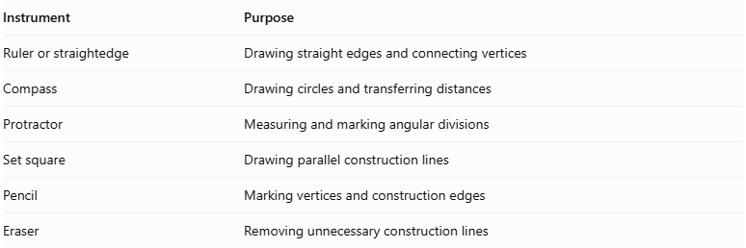
Instrument | Purpose
Ruler or straightedge | Drawing straight edges and connecting vertices
Compass | Drawing circles and transferring distances
Protractor | Measuring and marking angular divisions
Set square | Drawing parallel construction lines
Pencil | Marking vertices and construction edges
Eraser | Removing unnecessary construction lines
Construction method: Instrument-based geometric construction using geometric instruments, angular measurements, and geometric relationships. It does not use coordinate-based construction.

Instrument-Based Construction Procedures

Constructing the Upper Crossed Heptagram
# Source: AI Source: Provided by: [Data Path: Persons Table -> ID Column: 1, Name_En Column: Motasem Essam] -> From: [ChatGPT] on [7/25/2026]
- Draw a circle using a compass.
- Mark seven equally spaced points around its circumference.
- Number the vertices consecutively from 1 to 7.
- Connect every vertex to the vertex five positions ahead, wrapping around after vertex 7.
- Follow the connection sequence:
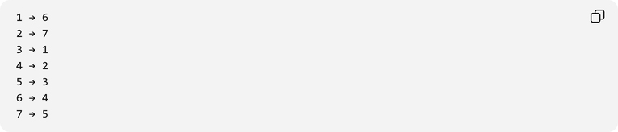
1 → 6
2 → 7
3 → 1
4 → 2
5 → 3
6 → 4
7 → 5
- Complete the upper star polygon $\{7/5\}$.

Constructing the Lower Crossed Tetradecagram
# Source: AI Source: Provided by: [Data Path: Persons Table -> ID Column: 1, Name_En Column: Motasem Essam] -> From: [ChatGPT] on [7/25/2026]
- Draw a second circle for the lower base.
- Mark fourteen equally spaced points around its circumference.
- Number the vertices consecutively from 1 to 14.
- Connect every vertex to the vertex five positions ahead, wrapping around after vertex 14.
- Complete the lower star polygon $\{14/5\}$.

Positioning the Two Bases
# Source: AI Source: Provided by: [Data Path: Persons Table -> ID Column: 1, Name_En Column: Motasem Essam] -> From: [ChatGPT] on [7/25/2026]
- Represent the two bases as parallel planes.
- Position the crossed heptagram above the crossed tetradecagram.
- Align their orientations according to the crossed cupola arrangement.
- Maintain seven-fold rotational symmetry around the central axis.

Constructing the Lateral Faces
# Source: AI Source: Provided by: [Data Path: Persons Table -> ID Column: 1, Name_En Column: Motasem Essam] -> From: [ChatGPT] on [7/25/2026]
- Connect the upper and lower base vertices according to the crossed heptagrammic cupola's face-adjacency pattern.
- Construct seven triangular lateral faces.
- Construct seven square lateral faces.
- Arrange the faces so that they follow the crossed star-cupola structure.
- Check that all connections follow the intended topology rather than adding arbitrary vertex-to-vertex edges.

Completing the Three-Dimensional Representation
# Source: AI Source: Provided by: [Data Path: Persons Table -> ID Column: 1, Name_En Column: Motasem Essam] -> From: [ChatGPT] on [7/25/2026]
- Darken the visible edges.
- Use dashed lines for hidden edges where appropriate.
- Preserve the crossed appearance of the star-polygon bases.
- Check the seven-fold symmetry.
- Verify that the triangular and square lateral faces form the intended closed star-cupola arrangement.
Construction accuracy note: A regular heptagon and regular tetradecagon cannot be constructed exactly using only an unmarked straightedge and compass. A protractor can be used for measured angular marking to produce an instrument-based drawing or model. This is not coordinate-based construction.

Key Points
# Source: AI Source: Provided by: [Data Path: Persons Table -> ID Column: 1, Name_En Column: Motasem Essam] -> From: [ChatGPT] on [7/25/2026]
- Alternative Name: 7/5-Cupola.
- Upper Base: Retrograde Heptagram $\{7/5\}$.
- Lower Base: Tetradecagram $\{14/5\}$.
- Lateral Faces: 7 Triangles and 7 Squares.
- Total Faces: 16.
- Total Edges: 35.
- Total Vertices: 21.
- Rotational Symmetry: Order 7.
- Classification: Non-convex Star-Cupola.

Main Classification
# Source: AI Source: Provided by: [Data Path: Persons Table -> ID Column: 1, Name_En Column: Motasem Essam] -> From: [ChatGPT] on [7/25/2026]
Solid Geometry
└── Types of Solids
└── Star-Cupola
└── Types of Star-Cupola
└── Crossed Heptagrammic Cupola

Conclusion
# Source: AI Source: Provided by: [Data Path: Persons Table -> ID Column: 1, Name_En Column: Motasem Essam] -> From: [ChatGPT] on [7/25/2026]
The Crossed Heptagrammic Cupola is a non-convex star-cupola characterized by its retrograde heptagrammic upper base, tetradecagrammic lower base, and crossed arrangement of triangular and square lateral faces. It has 16 faces, 35 edges, and 21 vertices, with sevenfold rotational symmetry.
Important distinction: The Crossed Heptagrammic Cupola $\{7/5\}$ is different from the ordinary Heptagrammic Cupola $\{7/3\}$. Both belong to the star-cupola family, but they use different vertex-connection patterns. <Cite refs={["turn432429search12","turn432429search6"]}/>

